**Assignment 2**

**Question 1: (Computer Center Staffing)** You are the Director of the Computer Center for Gaillard College and responsible for scheduling the staffing of the center. It is open from 8 am until midnight. You have monitored the usage of the center at various times of the day and determined that the following numbers of computer consultants are required.

|  |  |
| --- | --- |
| Time of day | Minimum number of consultants required to be on duty |
| 8 am–noon | 4 |
| Noon–4 pm | 8 |
| 4 am–8 pm | 10 |
| 8 am–midnight | 6 |

Two types of computer consultants can be hired: full-time and part-time. The full-time consultants work for eight consecutive hours in any of the following shifts: morning (8 am – 4 pm), afternoon (noon – 8 pm), and evening (4 pm – midnight). Full-time consult- ants are paid $14 per hour.

Part-time consultants can be hired to work any of the four shifts listed in the table. Part-time consultants are paid $12 per hour. An additional requirement is that during every time period, at least one full-time consultant must be on duty for every part-time consultant on duty.

1. Determine a minimum-cost staffing plan for the center. In your solution, how many consultants will be paid to work full time and how many will be paid to work part time? What is the minimum cost?
2. After thinking about this problem for a while, you have decided to recognize meal breaks explicitly in the scheduling of full-time consultants. In particular, full-time consultants are entitled to a one-hour lunch break during their eight-hour shift. In addition, employment rules specify that the lunch break can start after three hours of work or after four hours of work, but those are the only alternatives. Part-time consultants do not receive a meal break. Under these conditions, find a minimum-cost staffing plan. What is the minimum cost?

Hint: for this problem, you only need to formulate the LP problem without solving it.

**Solution:**

**Given:**

Types of consultant – Full time, Part time

Number of hours for full time worker = 8 hours/shift

Number of hours for part time worker = 4 hours/shift

Cost Co-efficient

Full time wages = $14/hour = $14 * 8 per shift

Part time wages = $12/hour = $12 *4 per shift

**Decision Variable:**

Let,

X1 = Number of full time consultant working on (8 am – 4 pm) Morning shift

X2 = Number of full time consultant working on (noon – 8 pm) Afternoon shift

X3 = Number of full time consultant working on (4 pm – midnight) Evening shift

Y1 = Number of Part time consultant working on (8 am – noon) Morning shift

Y2 = Number of Part time consultant working on (noon – 4 pm) Afternoon shift

Y3 = Number of Part time consultant working on (4 pm – 8 pm) Evening shift

Y4 = Number of Part time consultant working on (8 pm – midnight) Night shift.

**Objective Function:**

1. Minimum cost paid to work for each Full time and Part time consultant.

Minz = (14 * 8) (X1 + X2 + X3) + (12 * 4) (Y1 + Y2 + Y3 + Y4)

**Constraints:**

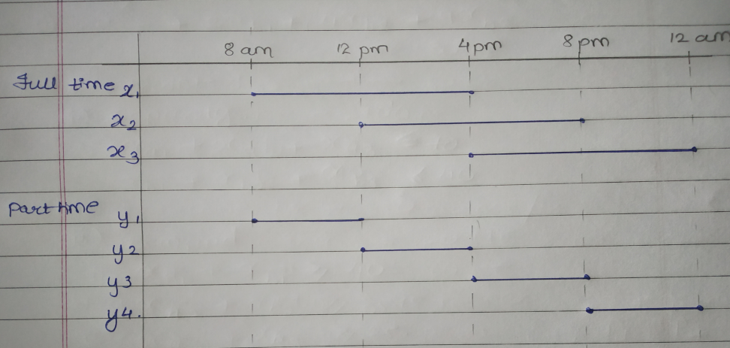

1. Minimum number of Consultants required

X1 + Y1 >= 4

X1 + X2 + Y2 >= 8

X2 + X3 + Y3 >= 10

X3 + Y4 >= 6

1. For every Part time Consultant at least 1 Full time consultant

X1 >= Y1

X1 + X2 >= Y2

X2 + X3 >= Y3

X3 >= Y4

**Mathematical Formulation of Linear Programming Problem:**

Let,

X1 = Number of full time consultant working on (8 am – 4 pm) Morning shift

X2 = Number of full time consultant working on (noon – 8 pm) Afternoon shift

X3 = Number of full time consultant working on (4 pm – midnight) Evening shift

Y1 = Number of Part time consultant working on (8 am – noon) Morning shift

Y2 = Number of Part time consultant working on (noon – 4 pm) Afternoon shift

Y3 = Number of Part time consultant working on (4 pm – 8 pm) Evening shift

Y4 = Number of Part time consultant working on (8 pm – midnight) Night shift.

Minz = (14 * 8) (X1 + X2 + X3) + (12 * 4) (Y1 + Y2 + Y3 + Y4)

Subject To

X1 + Y1 >= 4

X1 + X2 + Y2 >= 8

X2 + X3 + Y3 >= 10

X3 + Y4 >= 6

X1 >= Y1

X1 + X2 >= Y2

X2 + X3 >= Y3

X3 >= Y4

And

X1, X2, X3 >= 0

Y1, Y2, Y3, Y4 >= 0

1. There is a 1 hour break for every Full time worker after 3 or 4 hours of the shift. And the Part time worker does not update.

Thus we need to cut the cost of the break hour from the total cost.

**Objective function**

Thus the objective function is updated as:

**Minz = (14 * 8) (X1 + X2 + X3) – (14*1)(X1 + X2 + X3) + (12 * 4) (Y1 + Y2 + Y3 + Y4).**

**Constraints**

1. Minimum number of Consultants required

X1 + Y1 >= 4

X1 + X2 + Y2 >= 8

X2 + X3 + Y3 >= 10

X3 + Y4 >= 6

1. For every Part time Consultant at least 1 Full time consultant

X1 >= Y1

X1 + X2 >= Y2

X2 + X3 >= Y3

X3 >= Y4

**Mathematical Formulation of Linear Programming Problem:**

Let,

X1 = Number of full time consultant working on (8 am – 4 pm) Morning shift

X2 = Number of full time consultant working on (noon – 8 pm) Afternoon shift

X3 = Number of full time consultant working on (4 pm – midnight) Evening shift

Y1 = Number of Part time consultant working on (8 am – noon) Morning shift

Y2 = Number of Part time consultant working on (noon – 4 pm) Afternoon shift

Y3 = Number of Part time consultant working on (4 pm – 8 pm) Evening shift

Y4 = Number of Part time consultant working on (8 pm – midnight) Night shift.

Minz = (14 * 8) (X1 + X2 + X3) – (14*1)(X1 + X2 + X3) + (12 * 4) (Y1 + Y2 + Y3 + Y4).

Subject To

X1 + Y1 >= 4

X1 + X2 + Y2 >= 8

X2 + X3 + Y3 >= 10

X3 + Y4 >= 6

X1 >= Y1

X1 + X2 >= Y2

X2 + X3 >= Y3

X3 >= Y4

And

X1, X2, X3 >= 0

Y1, Y2, Y3, Y4 >= 0

**Question 2:** Back Savers is a company that produces backpacks primarily for students. They are considering offering some combination of two different models—the Collegiate and the Mini. Both are made out of the same rip-resistant nylon fabric. Back Savers has a long-term contract with a supplier of the nylon and receives a 5000 square-foot shipment of the material each week. Each Collegiate requires 3 square feet while each Mini requires 2 square feet. The sales forecasts indicate that at most 1000 Collegiate and 1200 Minis can be sold per week. Each Collegiate requires 45 minutes of labor to produce and generates a unit profit of $32. Each Mini requires 40 minutes of labor and generates a unit profit of $24. Back Savers has 35 laborers that each provides 40 hours of labor per week. Management wishes to know what quantity of each type of backpack to produce per week. Solve this problem graphically.

**Solution:**

**Given:**

Total shipment of material per week = 5000 sq. ft.

Material required for each Collegiate bag = 3 sq. ft.

Material required for each Mini bag = 2 sq. ft.

Sales forecast for Collegiate bag per week <= 1000 units

Sales forecast for Mini bag per week <= 1200 units

Cost Co-efficient:

Unit profit for Collegiate = $32

Unit profit for Mini = $24

Total labor hours = 35 labors * 40 hours = 1400 hours

1. **To define decision variable:**

Let, X1 = Quantity of Collegiate Bags to be produced per week.

X2 = Quantity of Mini Bags to be produced per week.

1. **Objective Function:**

Maximum Total Profit gained by Collegiate and Mini bags per week.

Maxz = 32X1 + 24X2

1. **Constraints:**
2. Total available Material

3X1 + 2X2 <= 5000 sq. ft.

1. Sales Forecast

X1 <= 1000 units

X2 <= 1200 units

1. Labor Hours

(45/60) X1 + (40/60) X2 <= 1400 hours - (45 min and 40 min are converted into hours)

1. **Mathematical Formulation of Linear Programming Problem:**

Let,

X1 = Quantity of Collegiate Bags to be produced per week.

X2 = Quantity of Mini Bags to be produced per week.

Maxz = 32X1 + 24X2

Subject to

3X1 + 2X2 <= 5000 sq. ft.

X1 <= 1000 units

X2 <= 1200 units

(45/60) X1 + (40/60) X2 <= 1400 hours

And

X1 >= 0, X2 >= 0.

**Graphical Solution:**

Consider,

3X1 + 2X2 = 5000

Let X1 = 0 to get the Y intercept and later X2 = 0 to get the X intercept.

2 X2 = 5000

X2 = 2500

Now

3 X1 = 5000

X1 = 1666.67

Therefore, **X1 = 1666.67, X2 = 2500**

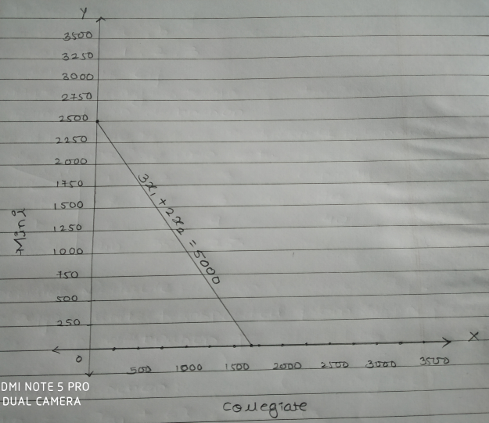

Consider,

(45/60) X1 + (40/60) X2 = 1400 hours

Let X1 = 0 to get the Y intercept and later X2 = 0 to get the X intercept.

(45/60) X1 = 1400

X1 = 1866.67

Now,

(40/60) X2 = 1400

X2 = 2100

Therefore, **X1 = 1866.67, X2 = 2100**

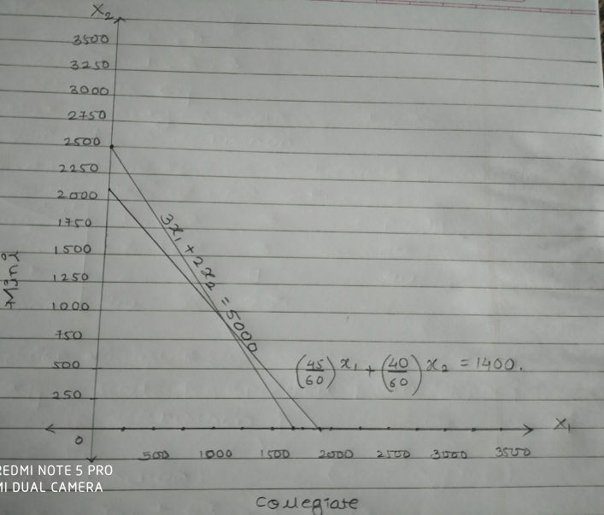

Also, we have

**X1 = 1000**

**X2 = 1200**

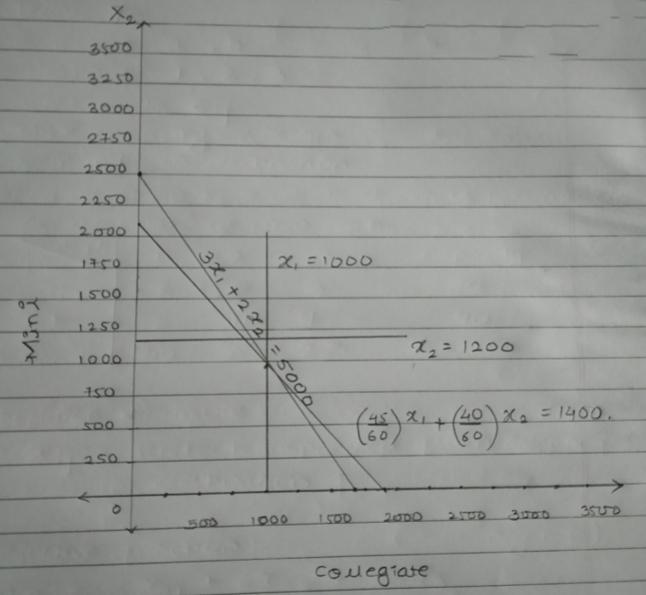

Feasible region for the plotted graph is as below shaded region.

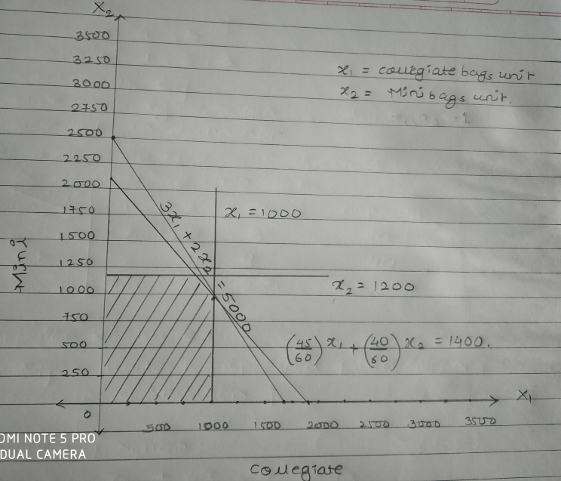

Consider the point (2500, 2000) or (1500, 1500) which does not form an optimal solution.

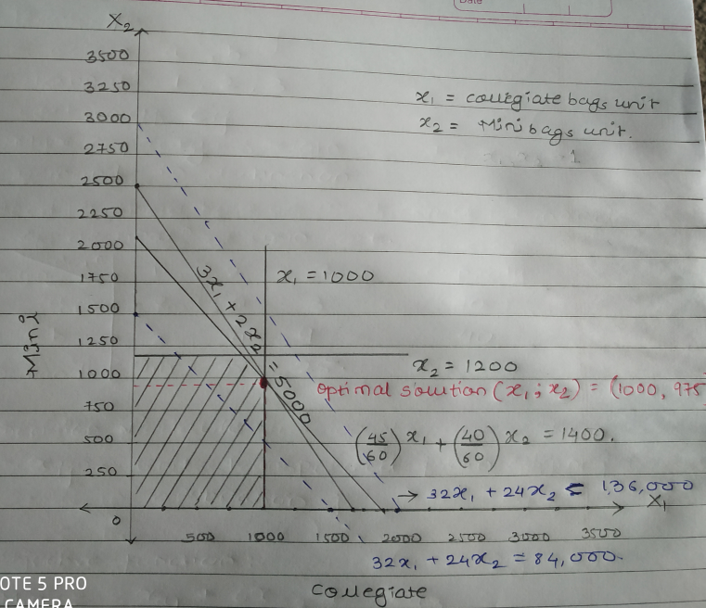

Since, the graph intersect the feasible region at a point (**1000, 974**) this point can be the feasible or optimal solution for the problem.

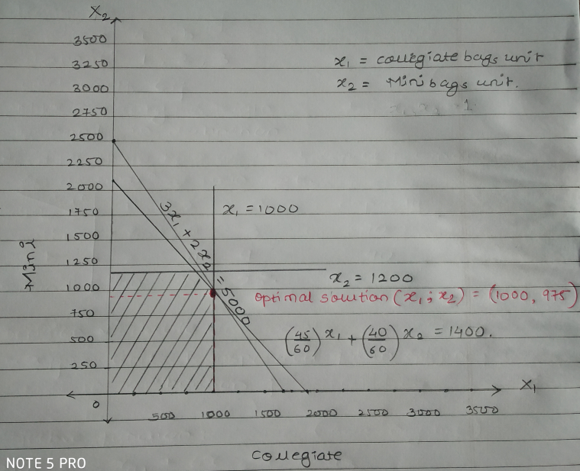

Hence, according to objective function:

Maxz = 32 X1 +24 X2

**X1 = 1000, X2 = 974** as optimal solution,

Maxz = 32 * 1000 + 24 * 97,

Maximum Profit = **$55376**

Therefore we have optimal solution for the problem where Bank Savers Company should produce **1000** units of collegiate bags and **975** units of Mini Bags to earn maximum profit of **$55,376.**

**Questions 3: (Weigelt Production)** The Weigelt Corporation has three branch plants with excess production capacity. Fortunately, the corporation has a new product ready to begin production, and all three plants have this capability, so some of the excess capacity can be used in this way. This product can be made in three sizes--large, medium, and small--that yield a net unit profit of $420, $360, and $300, respectively. Plants 1, 2, and 3 have the excess capacity to produce 750, 900, and 450 units per day of this product, respectively, regardless of the size or combination of sizes involved.  
 The amount of available in-process storage space also imposes a limitation on the production rates of the new product. Plants 1, 2, and 3 have 13,000, 12,000, and 5,000 square feet, respectively, of in-process storage space available for a day's production of this product. Each unit of the large, medium, and small sizes produced per day requires 20, 15, and 12 square feet, respectively.  
 Sales forecasts indicate that if available, 900, 1,200, and 750 units of the large, medium, and small sizes, respectively, would be sold per day.  
 At each plant, some employees will need to be laid off unless most of the plant’s excess production capacity can be used to produce the new product. To avoid layoffs if possible, management has decided that the plants should use the same percentage of their excess capacity to produce the new product.  
 Management wishes to know how much of each of the sizes should be produced by each of the plants to maximize profit.

* 1. Define the decision variables
  2. Formulate a linear programming model for this problem.
  3. Solve the problem using *lpsolve*, or any other equivalent library in R.

**Solution:**

**Given:**

Cost Coefficient:

Net Profit of Products of Large Size = $420

Net Profit of Products of Medium Size = $360

Net Profit of Products of Small Size = $300

Excess capacity produced by Plants all sizes per day:

Plant 1 = 750 units

Plant 2 = 900 units

Plant 3 = 450 units

In process Storage space of:

Plant 1 = 13,000 sq. ft.

Plant 2 = 12,000 sq. ft.

Plant 3 = 5,000 sq. ft.

Units produced per day:

Large = 20 sq. ft.

Medium = 15 sq. ft.

Small = 12 sq. ft.

Sales forecast – Units sold per day if available

Large = 900 units

Medium = 1200 units

Small = 750 units

1. **Decision Variable:**

Let,

Xij = Quantity of each sizes i of products produced by each plant j in Weigelt Corporation.

i = Sizes of products produced by Weigelt Corporation (Large, Medium, Small),

i = L, M, S

j = Plants in which the products are produced by Weigelt Corporation.

j = 1, 2, 3

1. **Objective function:**

To find the maximum total number of products produced in each size by each plant in Weigelt Corporation to gain maximum profit.

Maxz = 420 (XL1 + XL2 + XL3) + 360 (XM1 + XM2 + XM3) + 300 (XS1 + XS2 + XS3)

1. **Constraints:**
2. **Excess Capacity**

XL1 + XM1 + XS1 <= 750 units

XL2 + XM2 + XS2 <= 900 units

XL3 + XM3 + XS3 <= 450 units

1. **Storage Space**

20XL1 + 15 XM1 + 12 XS1 <= 13,000 sq. ft.

20XL2 + 15 XM2 + 12 XS2 <= 12,000 sq. ft.

20XL3 + 15 XM3 + 12 XS3 <= 5,000 sq. ft.

1. **Sales forecast**

XL1 +XL2 + XL3 <= 900 units

XM1 + XM2 + XM3 <= 1200 units

XS1 + XS2 + XS3 <= 750 units

1. **Avoid Layoff**

Same percentage of excess capacity to be used to produce new product thus the ratio of the excess capacities by every plants should be the same.

XL1 + XM1 + XS1 : 750 units :: XL2 + XM2 + XS2 : 900 units

XL2 + XM2 + XS2 : 900 units :: XL3 + XM3 + XS3 : 450 units

XL3 + XM3 + XS3 : 450 units :: XL1 + XM1 + XS1 : 750 units

Hence,

900(XL1 + XM1 + XS1) = 750(XL2 + XM2 + XS2)

450(XL2 + XM2 + XS2) = 900(XL3 + XM3 + XS3)

750(XL3 + XM3 + XS3) = 450(XL1 + XM1 + XS1)

1. **Mathematical representation of Liner Programming model:**

Let,

Xij = Quantity of each sizes i of products produced by each plant j in Weigelt Corporation

i = L, M,S

j = 1, 2, 3

Maxz = 420 (XL1 + XL2 + XL3) + 360 (XM1 + XM2 + XM3) + 300 (XS1 + XS2 + XS3)

Subject To,

XL1 + XM1 + XS1 <= 750 units

XL2 + XM2 + XS2 <= 900 units

XL3 + XM3 + XS3 <= 450 units

20XL1 + 15 XM1 + 12 XS1 <= 13,000 sq. ft.

20XL2 + 15 XM2 + 12 XS2 <= 12,000 sq. ft.

20XL3 + 15 XM3 + 12 XS3 <= 5,000 sq. ft.

XL1 +XL2 + XL3 <= 900 units

XM1 + XM2 + XM3 <= 1200 units

XS1 + XS2 + XS3 <= 750 units

900(XL1 + XM1 + XS1) - 750(XL2 + XM2 + XS2) = 0

450(XL2 + XM2 + XS2) - 900(XL3 + XM3 + XS3) = 0

750(XL3 + XM3 + XS3) - 450(XL1 + XM1 + XS1) = 0

Xij >= 0

R program ---- Continued.

Srushti Padade

spadade@kent.edu